**MINI PROJECT -2 - TREND APPLICATION DEPLOYMENT**

**Github URL :** [**https://github.com/Janani-977/Trend_Devops_Application**](https://github.com/Janani-977/Trend_Devops_Application)

Application:

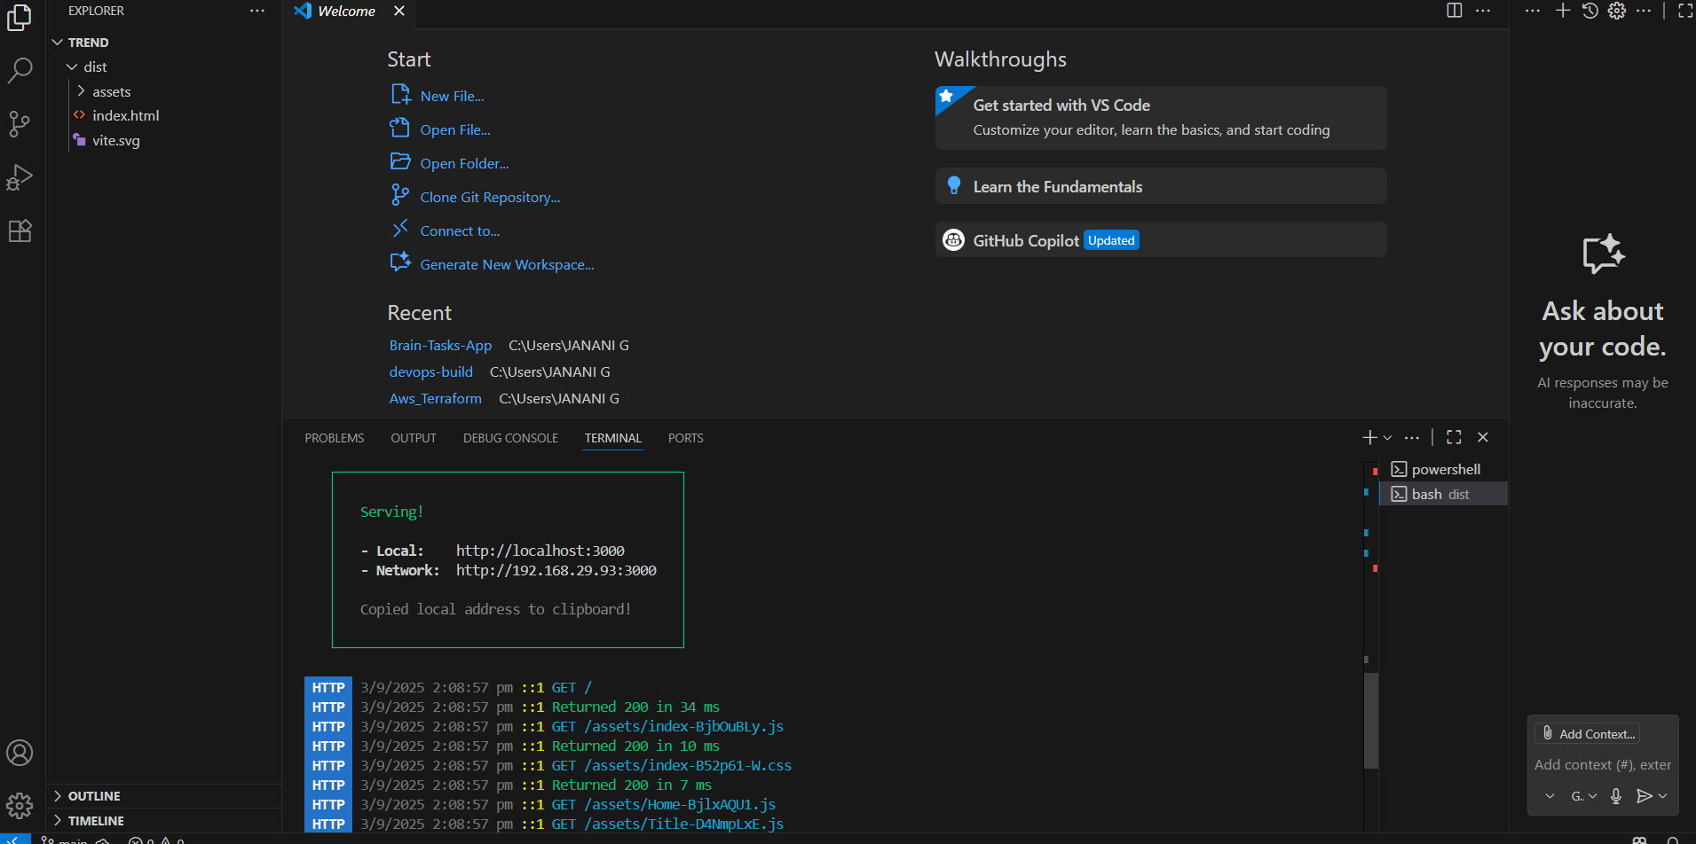

Able to view the app in port 3000 successfully

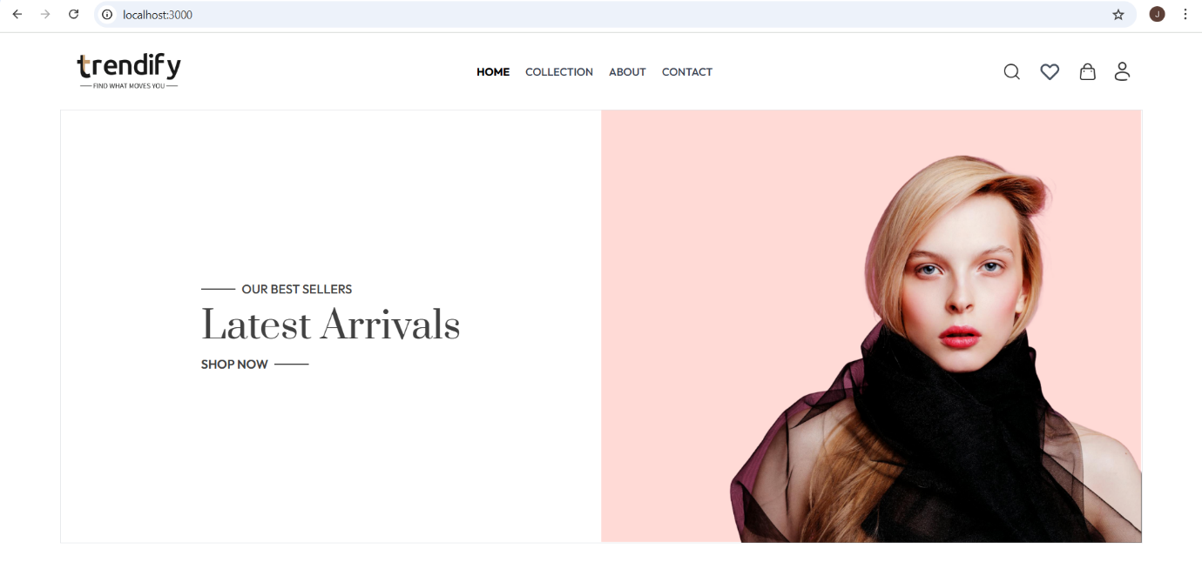

Docker :

Created a Dockerfile

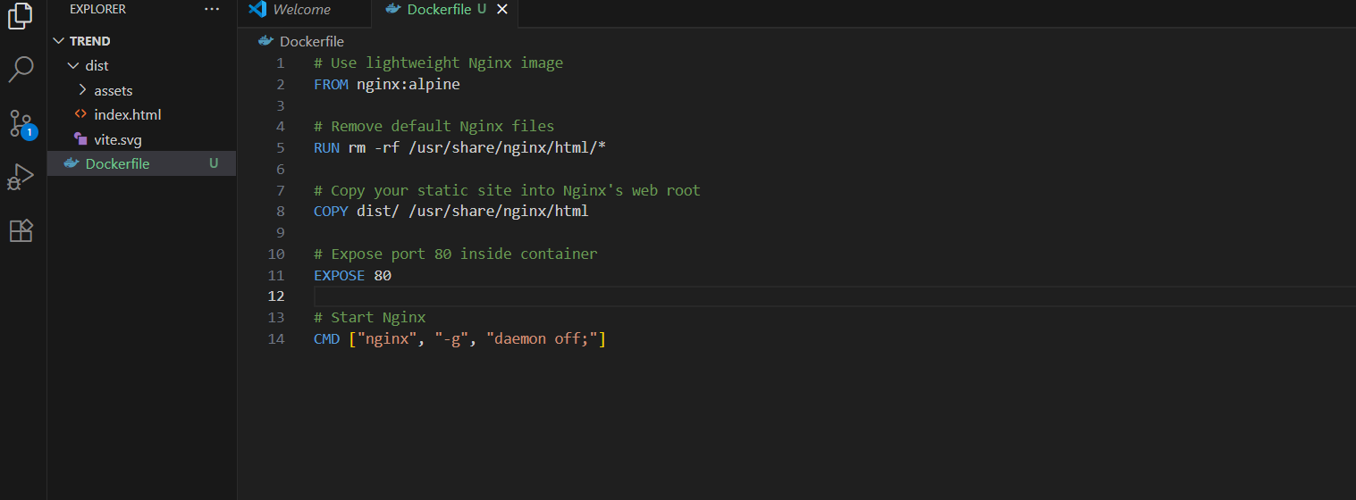

Build the image and run in the container

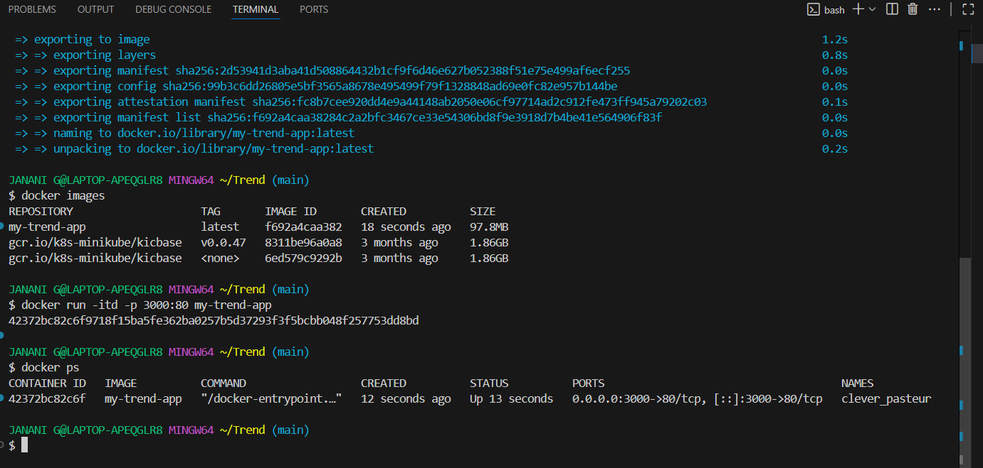

Able to view the app successfully

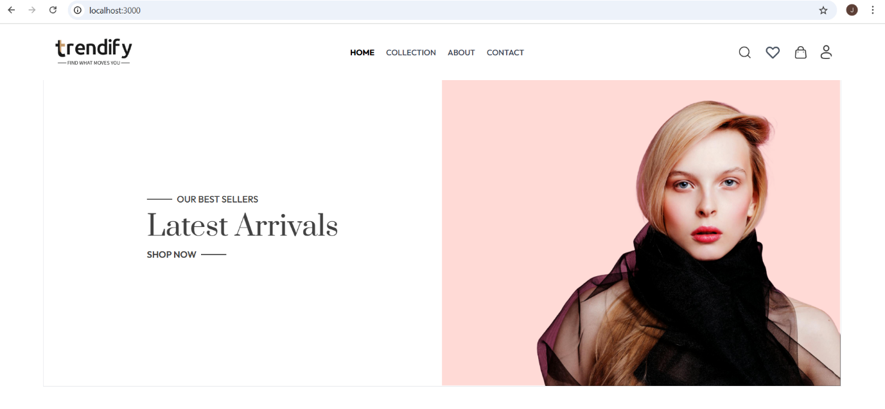

Docker Hub:

Created a dockerhub repo and pushed the image to check it works as expected.

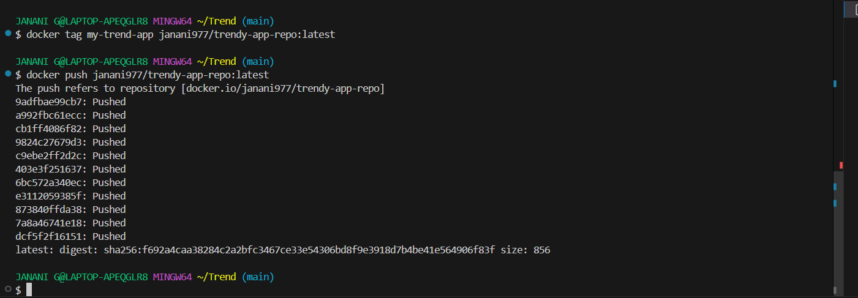

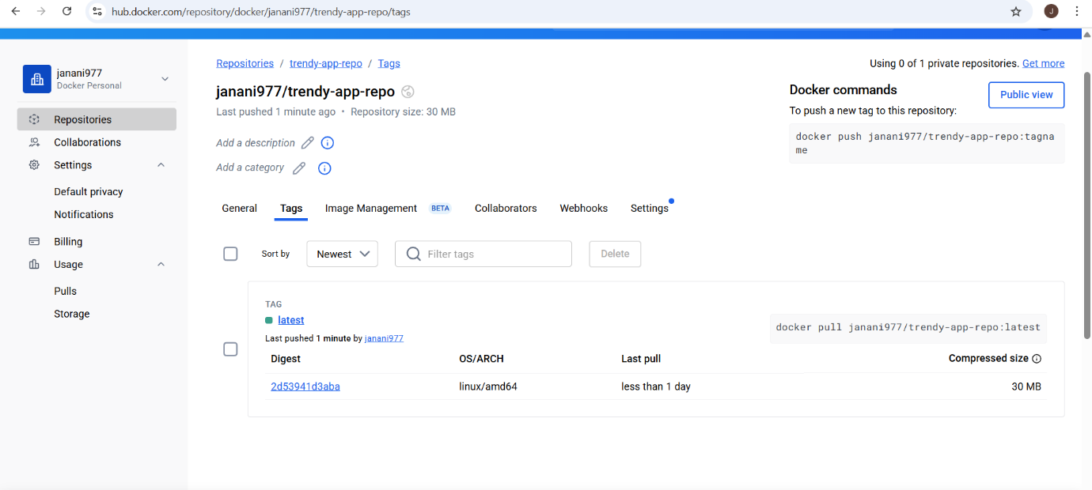

Terraform:

Created all resources

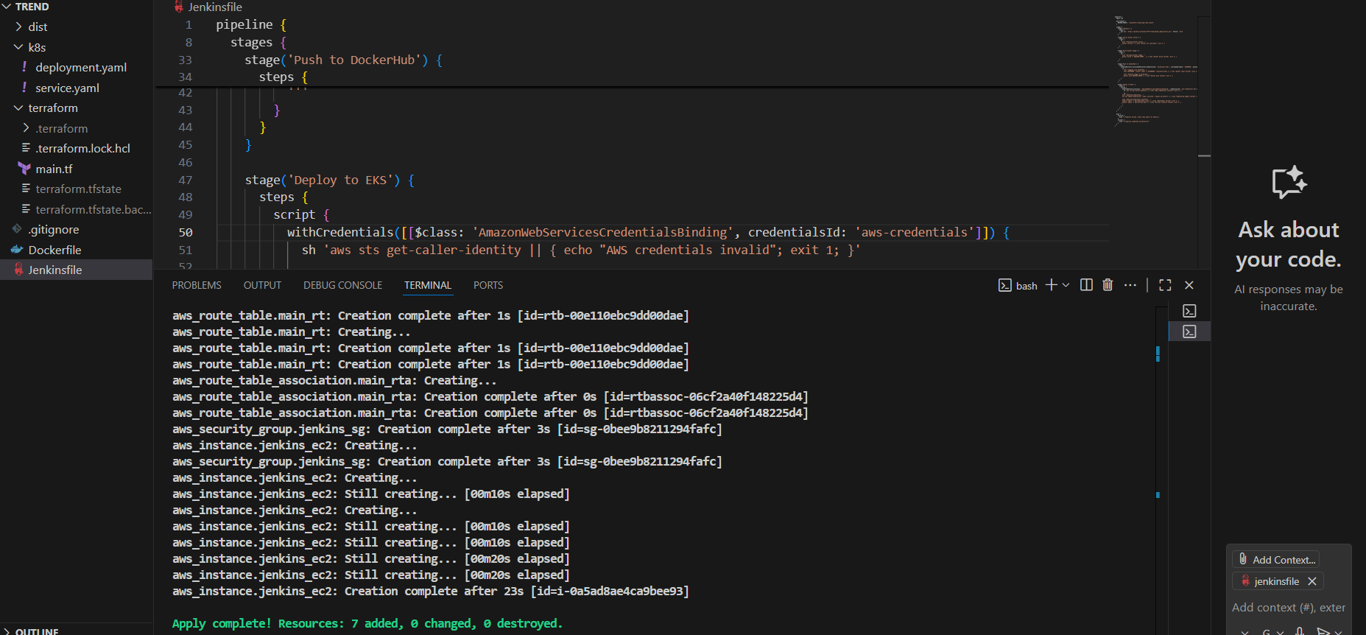

Created EC2

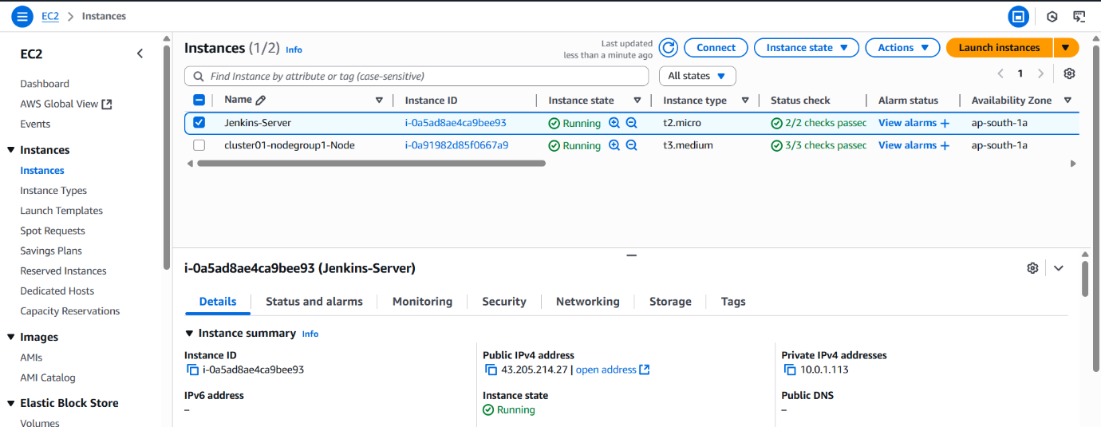

Created VPC

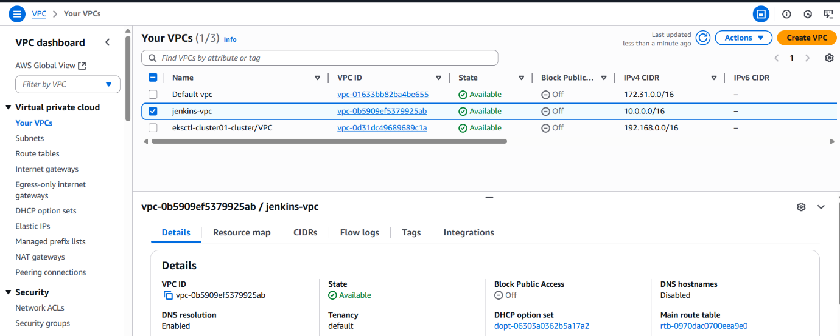

Created Subnet

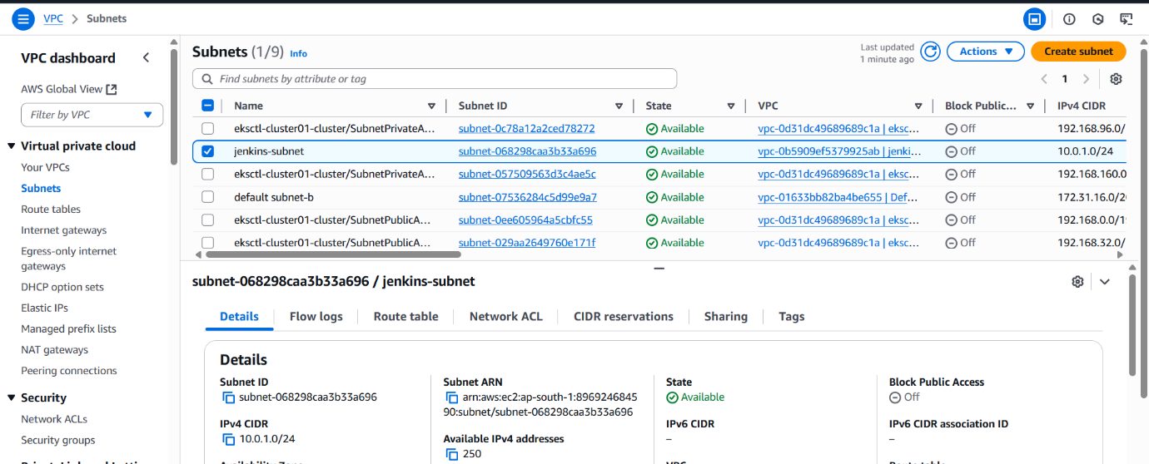

Route table

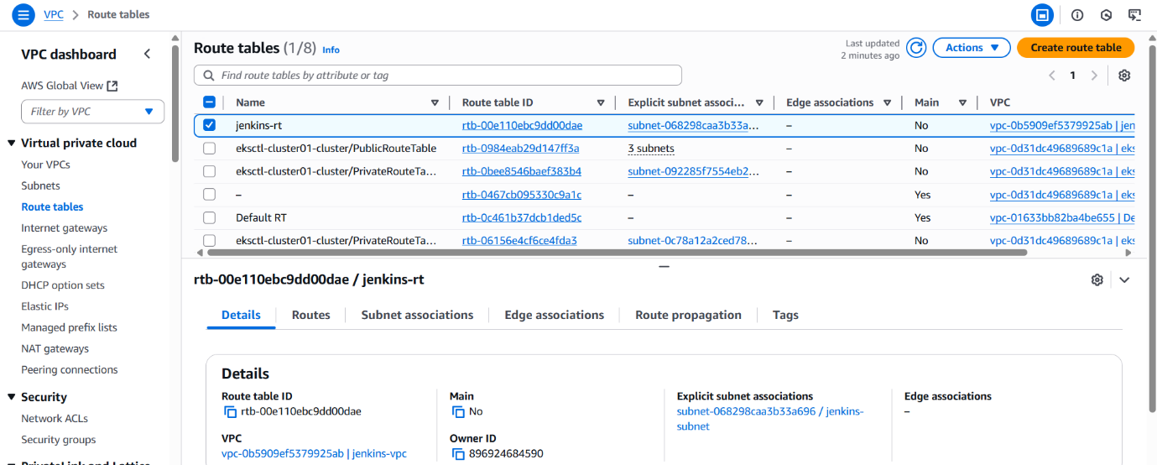

Internet gateway

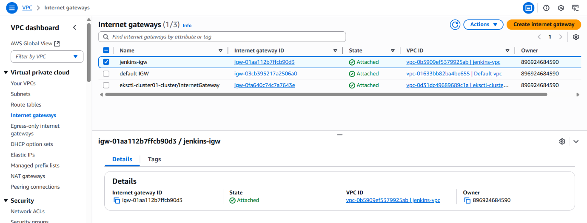

Created security group

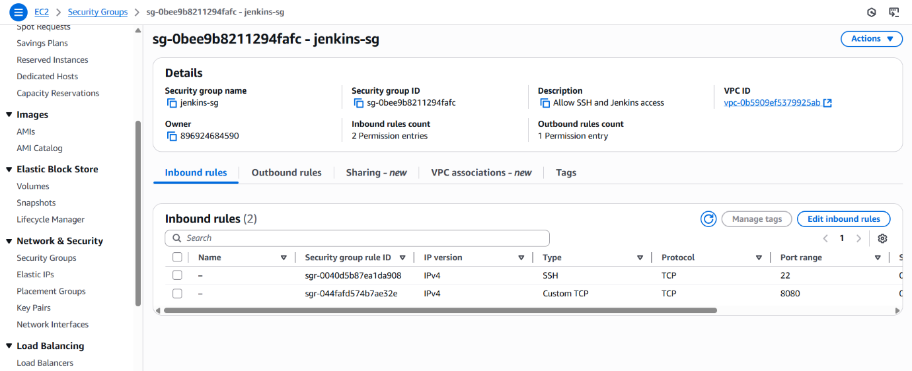

IAM Role Attached to EC2 with necessary permission

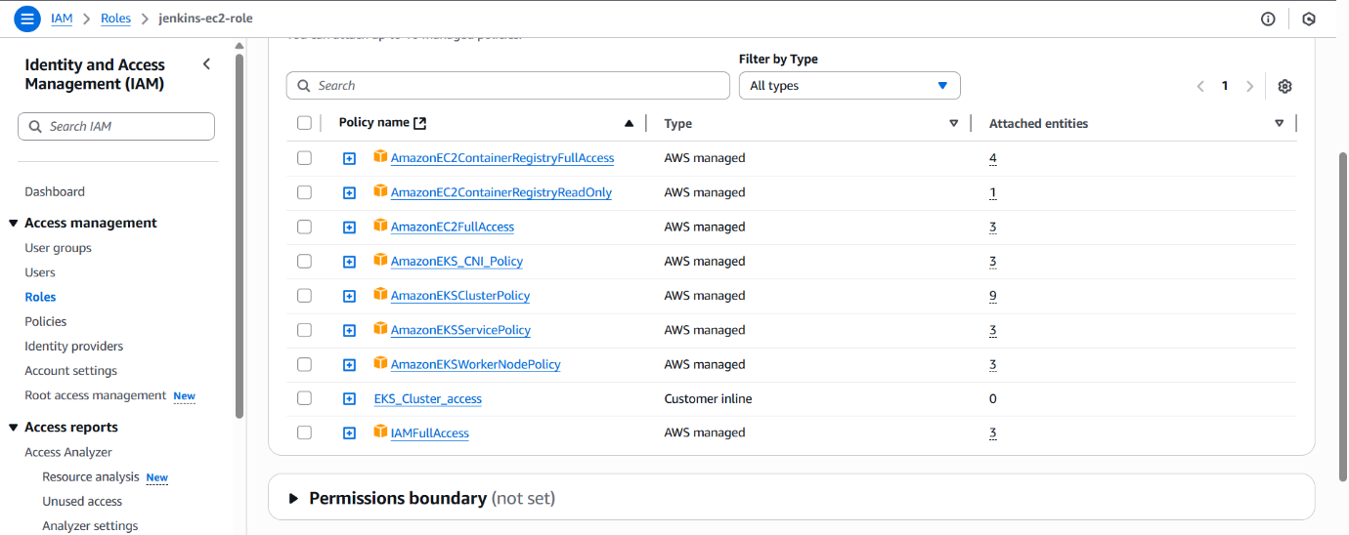

Jenkins login

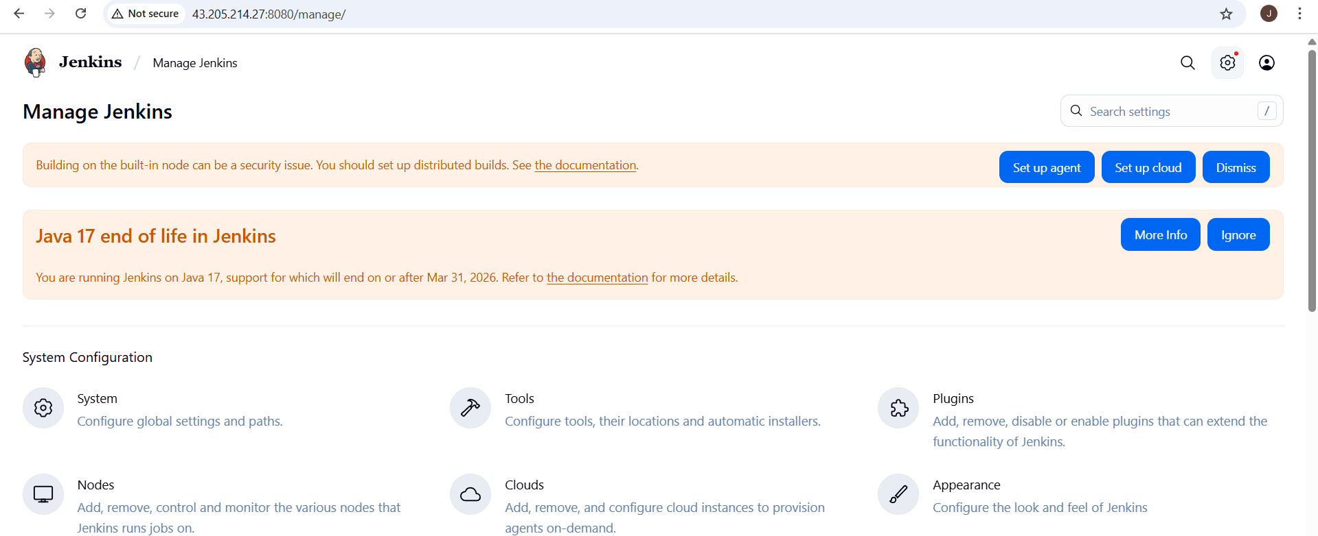

Kubernetes:   
Created deployment.yaml and service.yaml files and checked manually by deploying

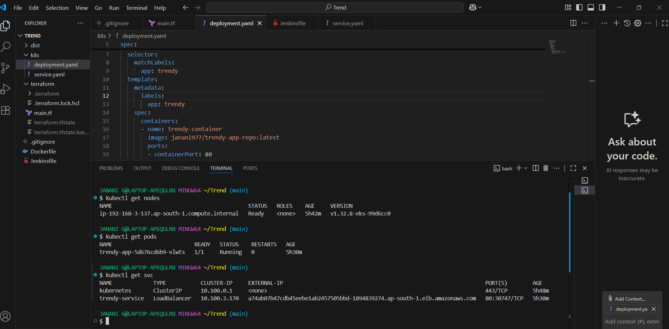

Created cluster

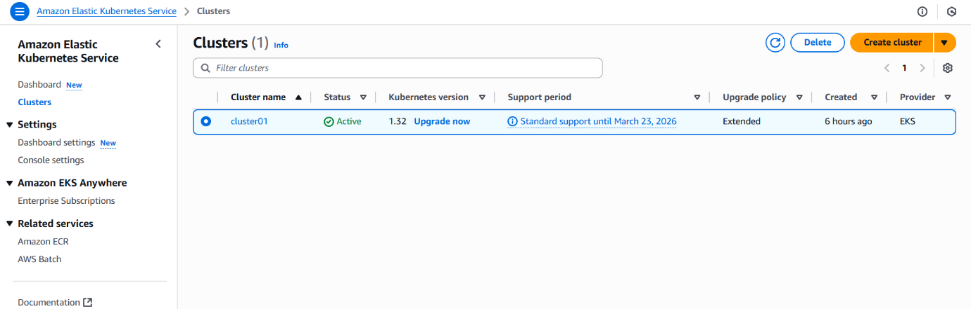

Created Nodegroup

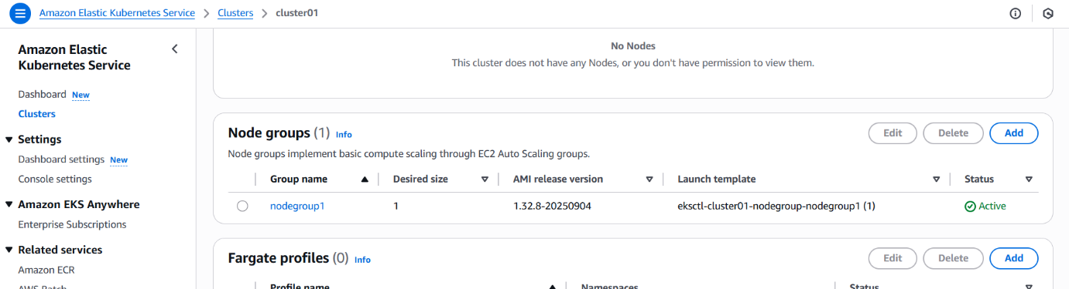

Checked via external IP(Load balancer)

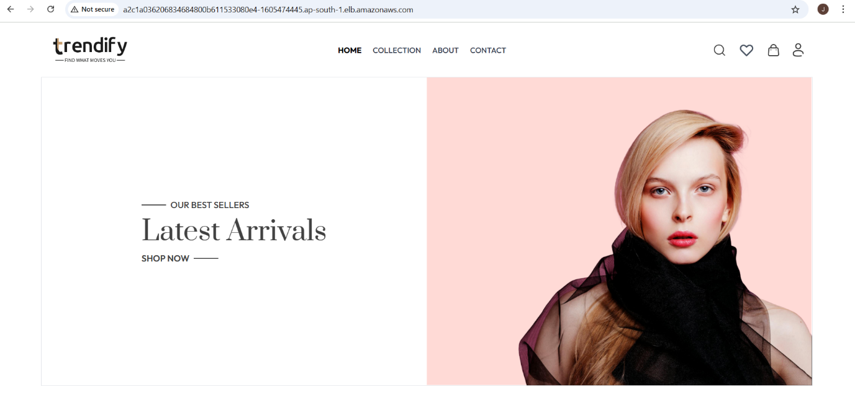

Jenkins:

Creating Jenkins pipeline

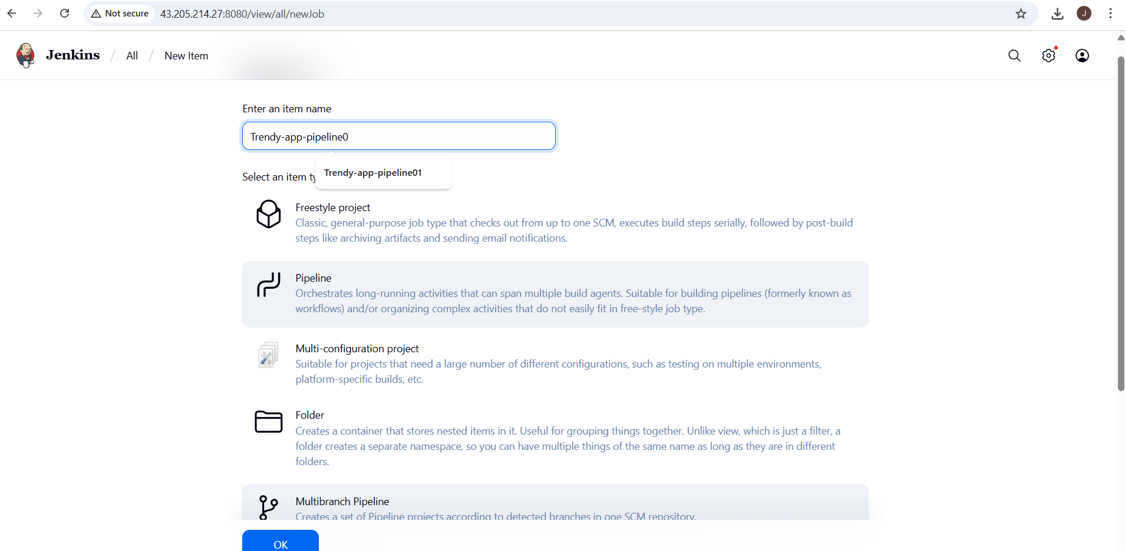

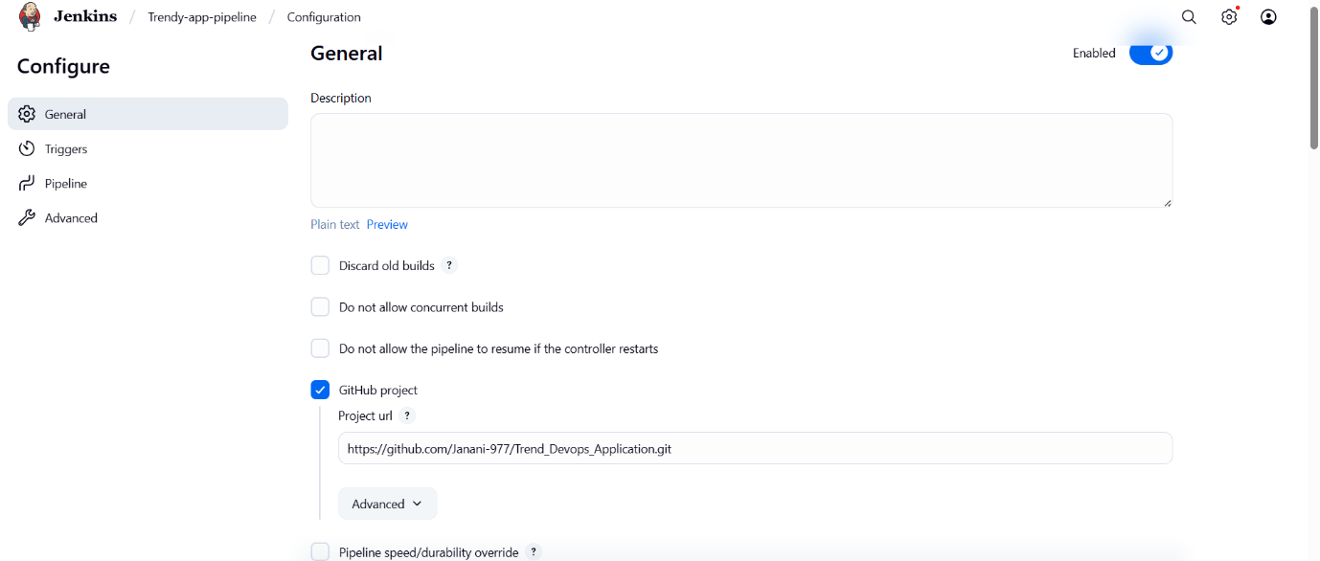

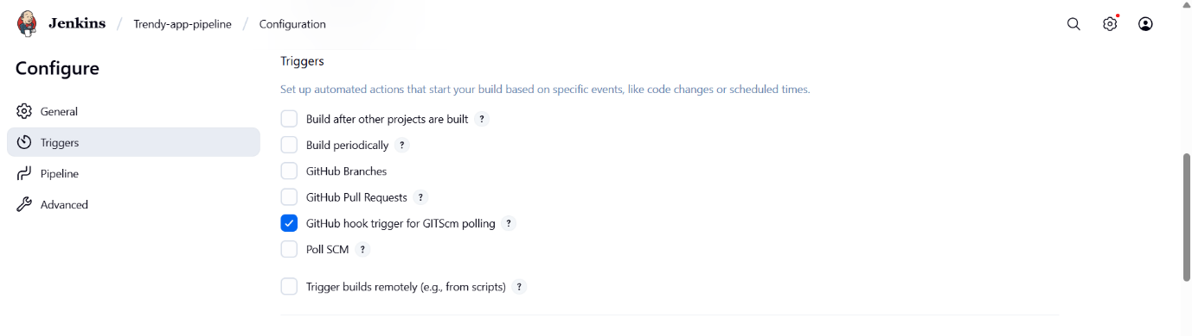

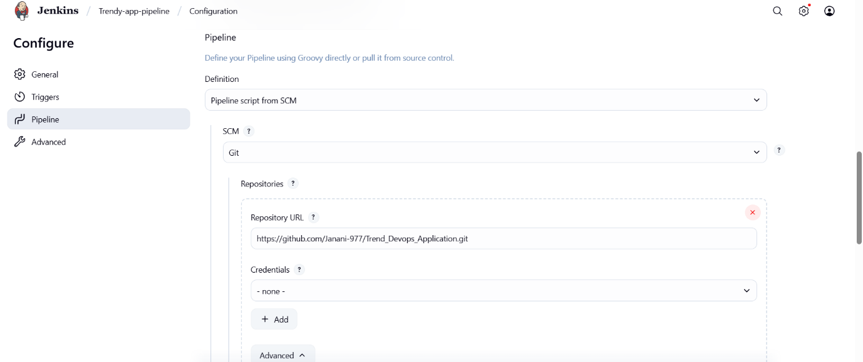

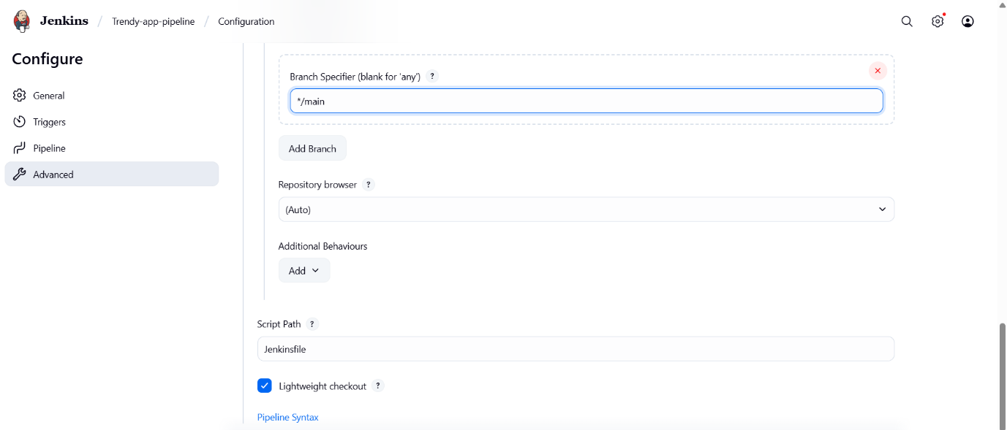

Pipeline got completed successfully

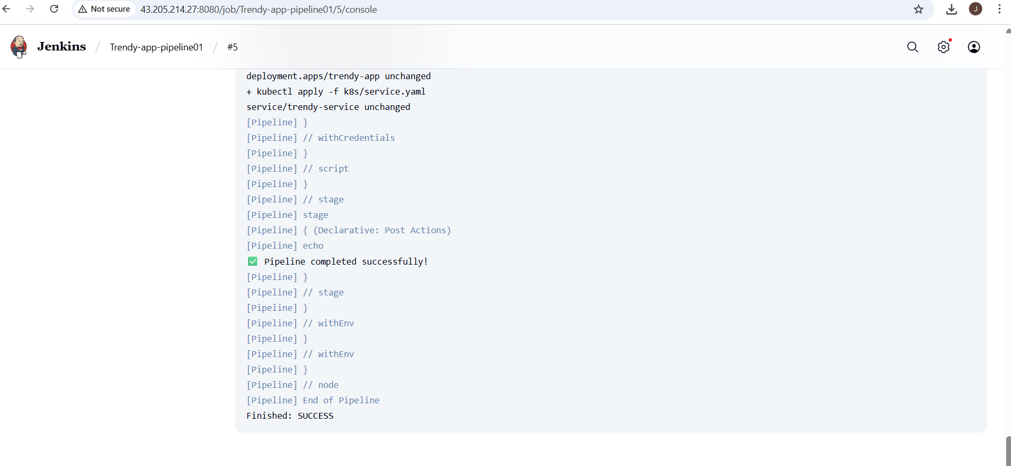

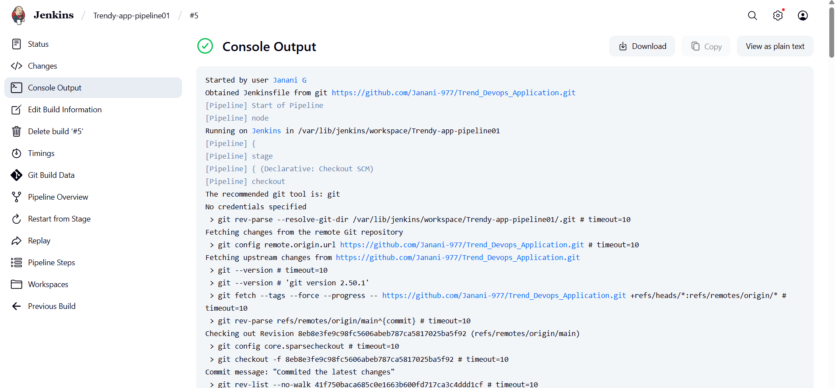

Image got pushed into dockerhub

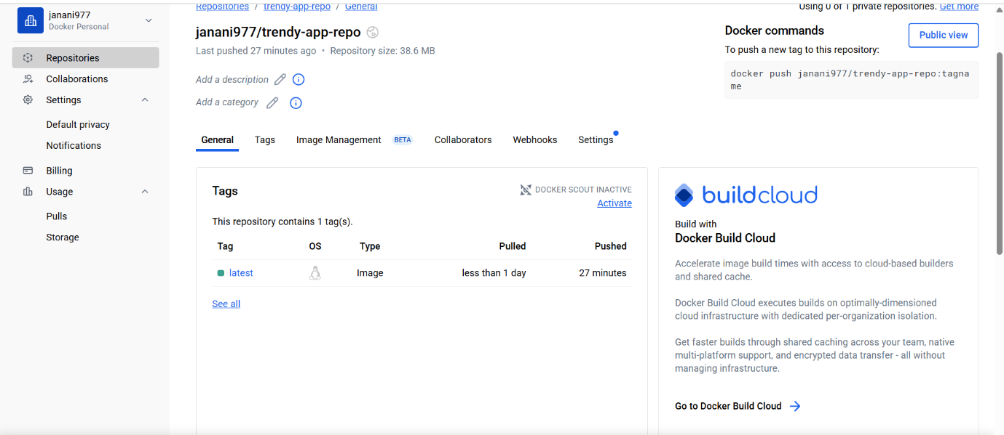

In EC2 terminal , able to check all the deployment, pod, nodes and svc details as expected

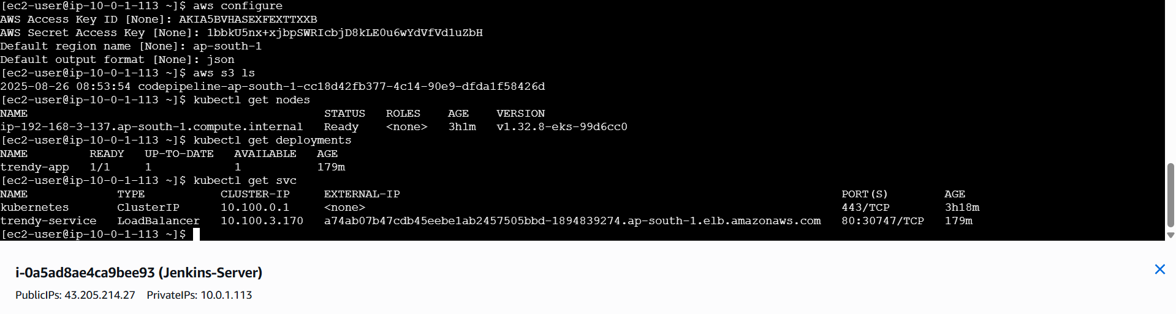

Checked the output using load balancer able to successfully view the application in browser

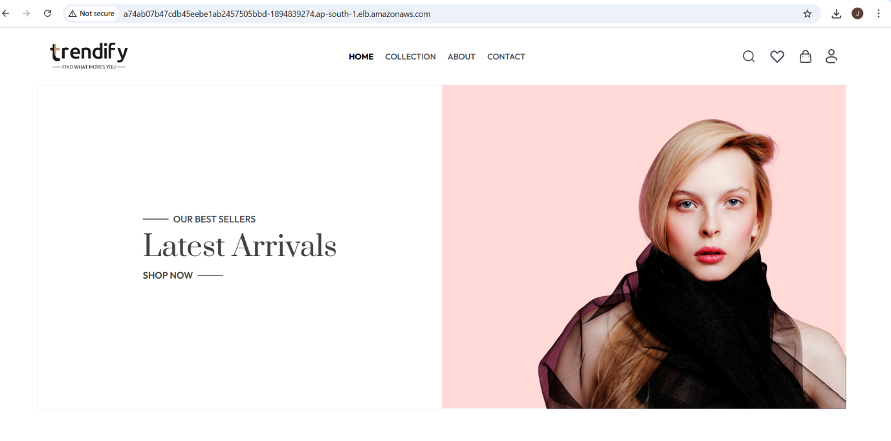

Github: Below is the latest repo with all required code pushed successfully

